Introduction
Wow! What a weird few months that was. I don’t about you but the summer holiday didn’t feel the way it usually does, maybe because life had been so different before. I didn’t get that breaking up from school for the summer feeling because I wasn’t in school!
The good news is we will get that ‘Whoop it’s the Christmas holidays’ feeling because we are going back to school in September. Life is getting more like it used to be. The reason for this is people like us have done the right things. We have kept ourselves and other people safe from corona virus. 😷 In a nutshell we are super heroes and need to remember in future if things are hard we can manage and will be okay.
Well done us!!!!
If you don’t believe me check out what Harry Hound has to say. Click here to go to his web page.
Not all schools will work exactly like Harry’s as every school is different. Your school will let you know if there are particular things you need to do. In this booklet there are somethings you can think about and some things to do to help you get yourself ready for September.

- Getting Started
What was lockdown like for you?

This is a good time to think about what lock down was like for you and then you can compare your experience with your friends when you meet up again.

Write all the things
you enjoyed about lock
down inside the heart.

In the box below write all the things you didn’t like.

What were the best bits of learning you did during lockdown? Write them here, as many as you like

Are you going to let your class teacher know what you have learnt? Teachers like to hear about that sort of thing.

Brag Board – You can use this whole page to write, draw, stick pictures whatever you like………..….of all the fabulous stuff you did when you were not in school.

- What will school be like when I go back?
Okay, let’s start with what you do know. List all the things either your school, your family or someone else has told you about going back to school. You could share your list with your family to see if they have heard the same things.
My list of stuff I know……….

Are there things you would like to know before you go back to school?
Make a list here.

How can you find out what you need to know? You might want to think about this with your family.
Okay let’s think about the practicalities of the new term.
How will I get to school?

Lots of us have been walking and cycling more during lockdown. To stay healthy it would be good if we kept doing this once things get back to normal. Can you walk or cycle to school?

Harry did a practice journey to school before he started back. You could do the journey to school before you go back in September to refresh your memory.

When you know how you are going to get to school tick here.

What time does school start?

That is up to each school. Some schools will have different groups of children starting at different times so everyone isn’t waiting in the playground or at the gate. The government still needs us to keep a distance between ourselves and other people so we won’t all be together in the same place, well not at first. We may be able to do that later. School may end at different times for different groups for the same reason.

When you know what times you will start and finish school tick here.

Who will I be with in school?
That depends on your school. As I said before we still need to keep apart from each other. Many schools are dividing the children into bubbles. This means you will be with the same children, teachers and teaching assistants in the same room for all of your lessons. These groups are being called bubbles; you may have heard people talking about these. If you want to know more about bubbles click here.

Will I get break and lunchtime?
Yes you will, we can’t work non- stop. You can take your own packed lunch or have a school meal. Some schools will be having different groups of children on break and lunch at different times, again so we can stay a healthy distance from each other.
Now the important bit. Have you thought about what you would really like in your packed lunch on the first day back? Or do you have favourite school lunch that you really hope will be on the menu on the first day? (I always really liked school custard, really I did.)
Make a note of your favourite packed lunch or meal here.
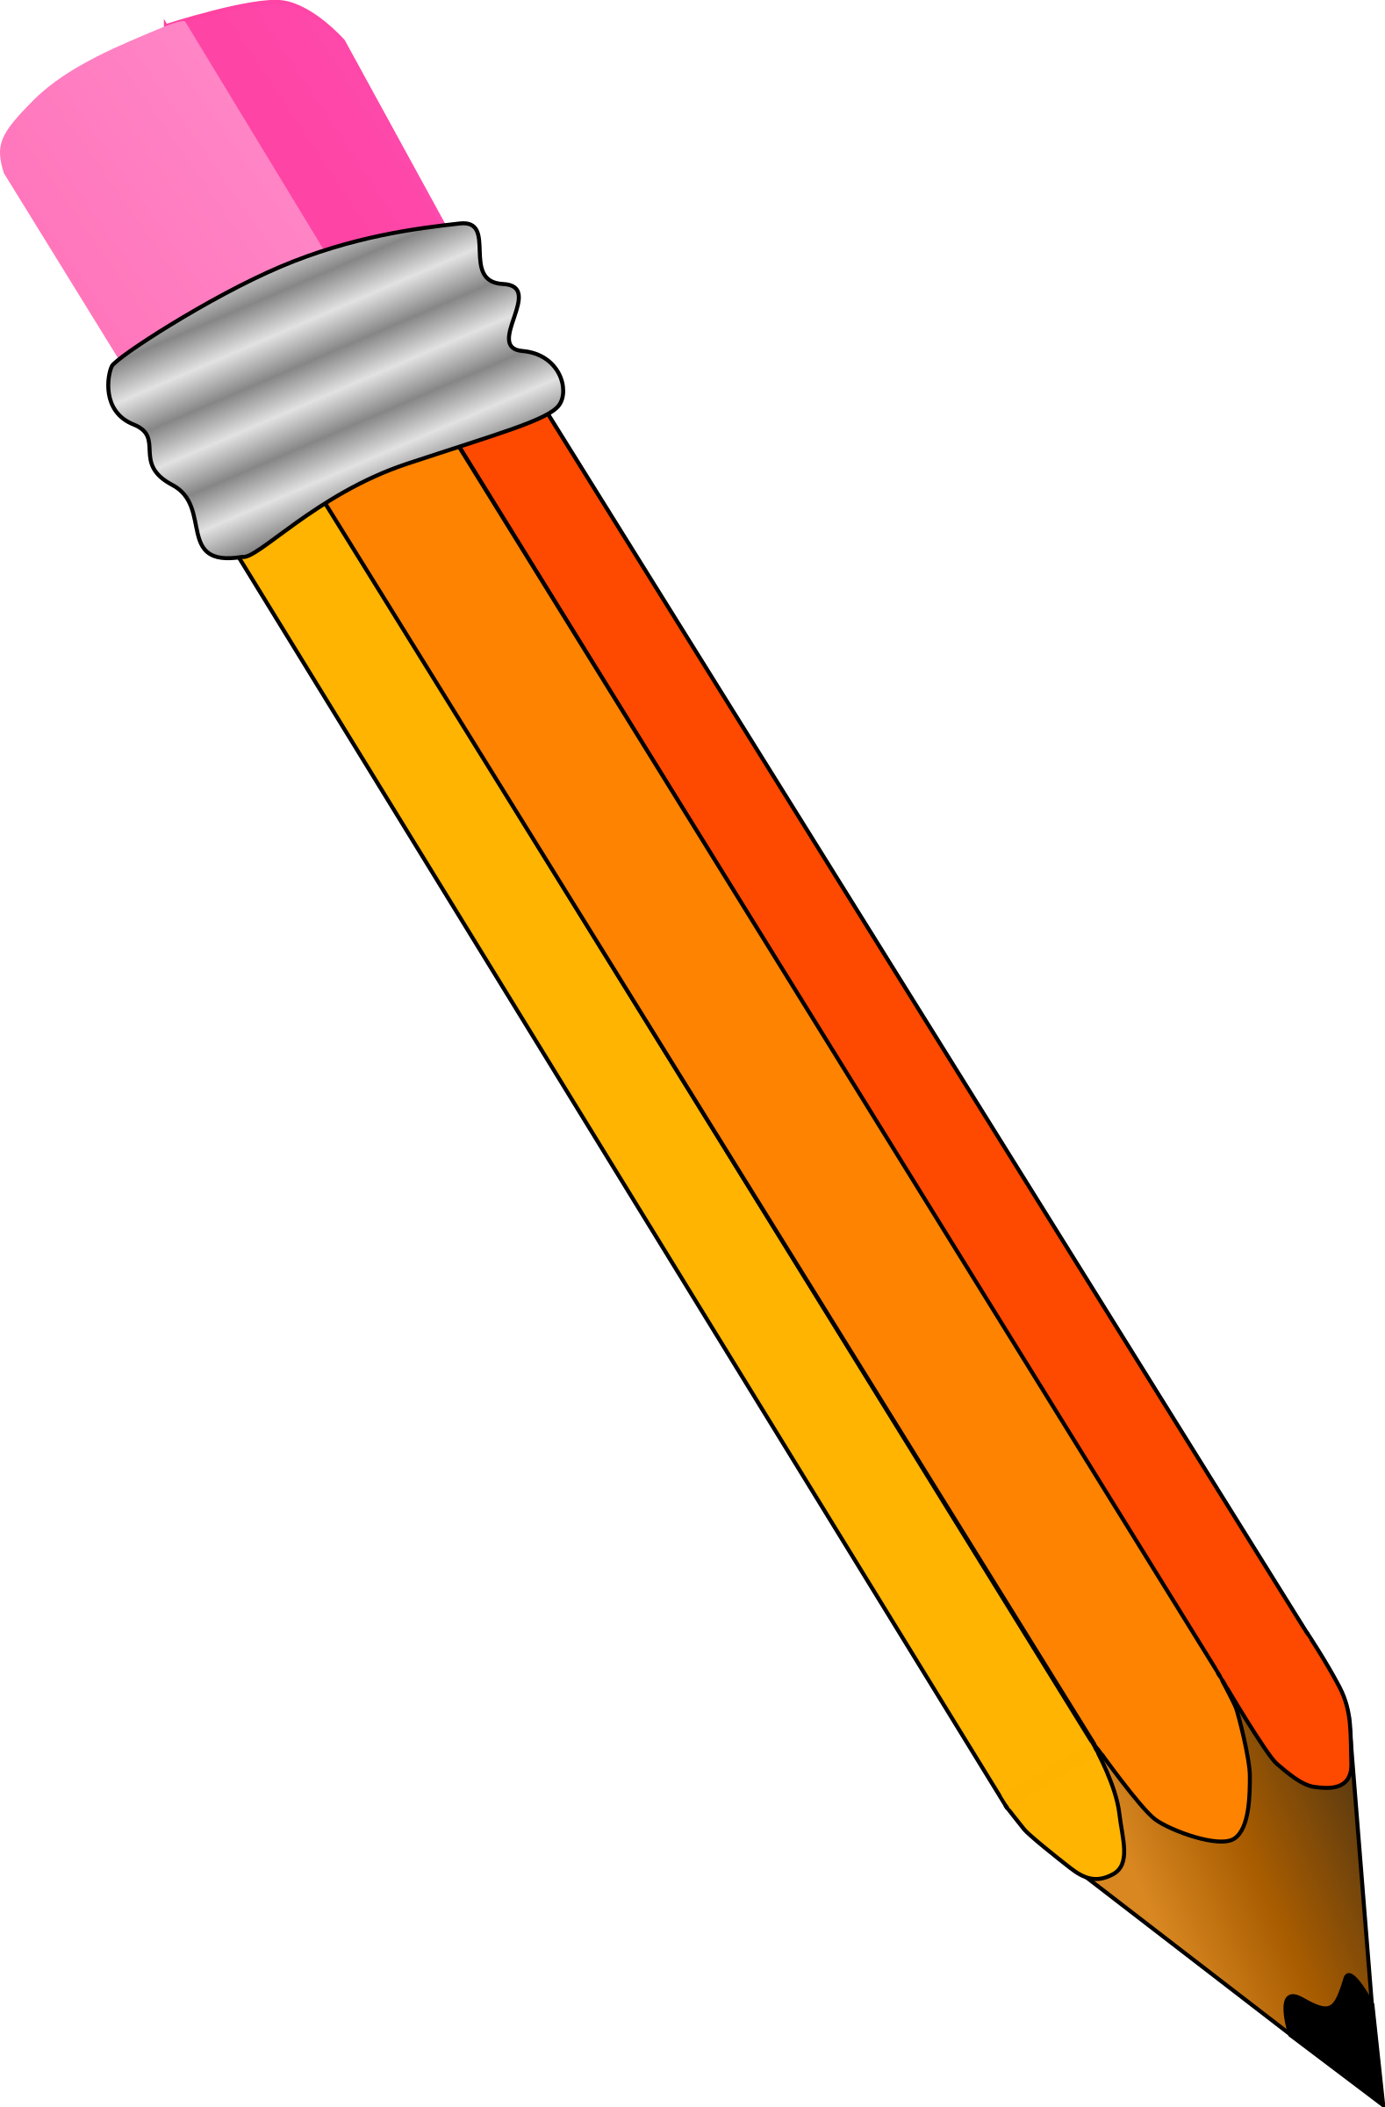
………………………………………………………………………………………………………………………………………………………………………………………………………………………………………………………………………………………………………………………………………………………………………………………………………………………………………
Can I take my own things to school?
The government have said it will be alright to take your own bag, pencil case and such but only the things you really need. The difference will be that there will probably not be as much equipment out in your classroom as usual. All schools are reducing the amount of equipment that is shared between pupils as it all has to be cleaned, which slows down lessons quite a bit. As things get back to normal more equipment will come back into classrooms so don’t worry about your favourite things they are not gone forever. Remember you will have moved up a class as this is a new school year so things would have been different anyway. Changes are what help make life exciting.
What do I have to wear?
That depends on your school. If you have a uniform you will wear that, if not wear your own clothes as you did last year. Actually, let’s think about it. Will you still fit into these clothes? I don’t mean just have you eaten too many biscuits during lock down (like I have) but it could be five months since you have been in school. You could have grown. Better do what Harry did and check they still fit. Also, you might just want to remember the feel of your school clothes before you put them on again in September.
Okay so that’s the practical things about going back to school. Some of it is just the same as every year when you go back to school, somethings are different and some are the same. Do you think there are more things the same or more differences this year? You could fill in this table to compare whether there are more changes or more things that are the same as usual.
What would usually happen at the start of a new school year. | Different to what would usually happen at the start of the new school year.
e.g. I have a new teacher | e.g. there are fewer children in my class.

And finally……
Do you have everything you need to go back to school in September? Make a list of what you need on your first day and tick them when you know you have them. Make a plan with your family to buy anything you need that you do not have.
……………………………………………………………………………………………………………………………………………………………………………………………………………………………………………………………………………………………………………………………………………………………………………………………………………………………………………………………………………………………………………………………………………………………………………………………………………………………………………………………………………………………………………………………………………………………………………………………………………………………………………………………………………………………………………………………………………………………………………………………………………………………………………………………………………………………………………………………………………………………………………………………………………………………………………………………………………………………………………………………………………………………………………………………………………………………………………………………………………………………………………………………………………………………………………………………………………………………………………………………………………………………………………………………………………………………………

- Is it safe to go back to school?
Yes, it is. If it wasn’t safe your family, teachers and the government wouldn’t be letting you go back. Your head teacher will be keeping a very close eye on what is happening in school and will make any changes that are necessary.
What school has done to keep you safe.
- They have grouped you into small bubbles of children and teachers so you have contact with fewer people.
- Classrooms will look different. Tables may be all facing the front of the room and not in groups. Equipment and some furniture will have been removed so there is more space for you to move around in the classroom
- Schools will be cleaned more often; this includes equipment in classrooms and in the playground that you share with other children
- Schools will give you time during the day to wash your hands more often than you would usually.
- Schools will probably have some new rules about queuing and moving in and out of school. Your teachers will let you know if there are new things to remember and will be there to remind you and help you do the right thing.
- Your school will be very strict telling anyone who may be feeling unwell, or may have people in their family who are poorly, to stay at home until they are better.
What you need to do to keep yourself safe.
I’m not going to fill these in. You have been doing these things for months now and you are really good at keeping yourself safe. Write down the most important things you can do to keep yourself and your friends safe at school.

……………………………………………………………………………………………………………………………………………………………………………………………………………………………………………………………………………………………………………………………………………………………………………………………………………………………………………………………………………………………………………………………………………………………………………………
(If you need a clue click here………… and here.)
I don’t think that you will need to wear a mask in school. You may see some staff wearing them. Don’t panic it does not mean they are ill. People who are unwell will be staying at home. Sometimes adults need to wear masks if they are talking to each other. It is the same person that you know, it’s just they have a mask on. If you are not sure look at their eyes. You may not see them smiling like usual but you can see their eyes smiling. Have a look at your family with their mask on and then without their mask, see what I mean, it’s still the same person.

So that’s it, you’re ready to go back to school. It will be half term before we know it. Until then enjoy the rest of your summer holidays and have a great start to the term.

